SESSION – 1

INTRODUCTION

1. What is DevOps?

* DevOps=Development + Operations.
* DevOps is a culture or process.
* To automate the application, build, and deployment process.
* By using DevOps culture, we can establish collaboration between development and operational teamwork.
* By using DevOps culture, we can speed up application delivery.
* DevOps is a set of Tools.

1. Why DevOps?

* To ensure the project or product to the client on time by ensuring the quality with continuous testing and monitoring.
* Quicker deployment cycles.
* Increase in product quality.
* Faster innovation cycles.

1. Symbol of DevOps?

* The DevOps symbol is **Infinity.**

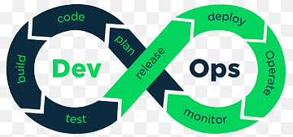

* Task done by developers:

1. Planning
2. Coding
3. Build
4. Test

* Task is done by the operational team:

1. Deploy
2. Monitor
3. Operation.
4. What is SDLC?

* SDLC means Software Development life cycle.
* SDLC is a structured process that enables the production of high-quality, low-cost software, in the shortest possible production time.
* AIM: SDLC is to produce superior software that meets and exceeds all customer expectations and demands.

In SDLC we have different phases:

1. Planning
2. Requirements Analysis
3. Design
4. Coding
5. Testing
6. Deployment and
7. Maintenance.

1. Meaning of Developer

* Writes code, creates software applications, and solves specific programming issues.

1. Meaning of operational team

* The operations team often manages the IT environment, quality assurance, and system and network infrastructure.
* It allows a team to handle the complete application lifecycle from development to deployment.

1. Explain the tools in DevOps.

The use of DevOps tools is to automate the application build and deployment process.

* **Maven:** It is a build tool.

                                               We can create a project structure.

* **Git Hub:**                  It is a repository server.

                                              Git Hub is a version control software

                                              It is used to store project source code

                                              All the developers will keep the project code in the git hub repo

                                              The DevOps team should take the code from the git hub repo.

* **SonarQube:**            It is code review software.

                                             For code quality check we will use SonarQube.

                                             SonarQube will identify the issues below in the project co

                                             Potential bugs, Duplicate code blocks, unit testing report.

* **Jenkins:** Jenkins is the heart of the DevOps.

                                              It is CI/CD software.

[continuous integration and continuous Deployment]

                                              In Jenkins, we will create jobs to perform build and deployment.

                                     By using Jenkins, we can automate the build and deployment process .

* **Apache Tomcat:**     It is a server

                                             Tomcat web server is used to deploy web applications.

* **Ansible:**By using Ansible we can restart 100 servers in one minute

It is used for configuration management.

* **Terraform:**It is used to create infrastructure as code.

* **Docker:**It is a containerization software

                                               It is used to run applications using containers.

                                               It will simplify the application deployment process.

* **Kubernetes:** It is also called K8S

                                               It is an Orchestration platform

                                               To scale our docker containers we are going to use Kubernetes.

1. What is Cloud?

* The cloud is an extensive network of remote servers around the world. These servers store and manage data, run applications, and deliver content and services like streaming videos, webmail, and office productivity software over the internet.

1. What is cloud computing?

* Cloud computing is the on-demand delivery of IT Resources over the Internet with pay-as-you-go pricing.

1. What are the types of cloud computing?

* There are two types of cloud computing:

1. Service model
2. Deployment model

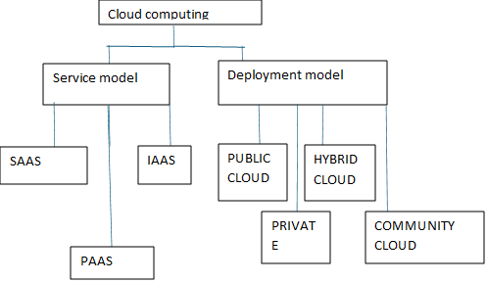

* The service model divided into three types

1. SAAS: Software as a service
2. PAAS: Platform as a service
3. IAAS: Infrastructure as a service.

* The deployment model is divided into four types:

1. **Public Cloud:** The public cloud is defined as computing services offered by third-party providers over the public internet.

1. **Private cloud:** A private cloud is a cloud computing deployment model where all cloud resources are dedicated to a single customer or user organization.

1. **Hybrid cloud:** A hybrid cloud is a mixed computing environment where applications are run using a combination of computing, storage, and services in different environments.
2. **Community cloud:** Community cloud is a cloud infrastructure that allows systems and services to be accessible by a group of several organizations to share information.